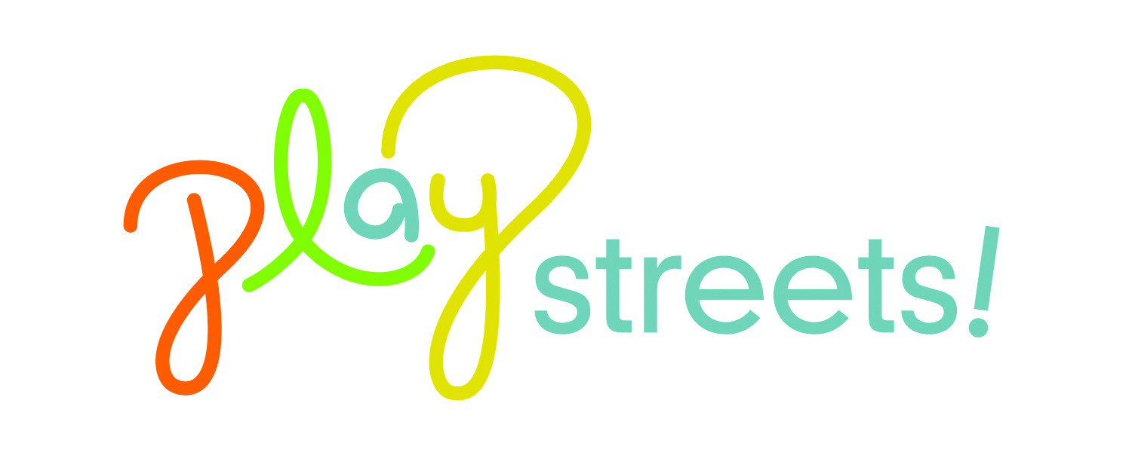
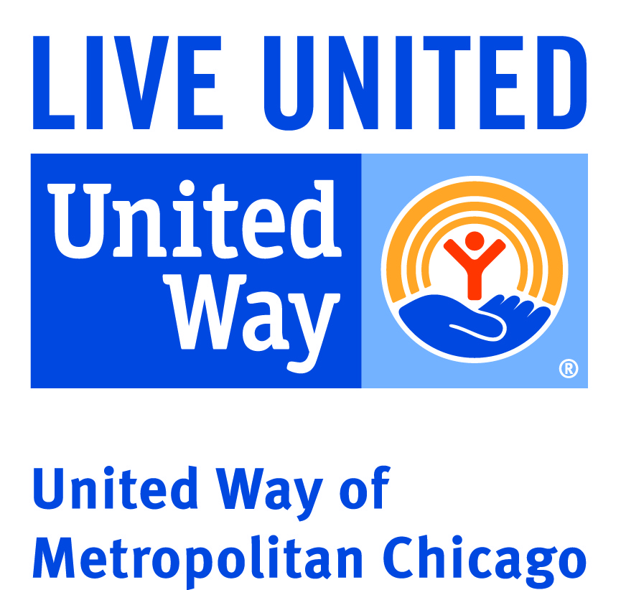
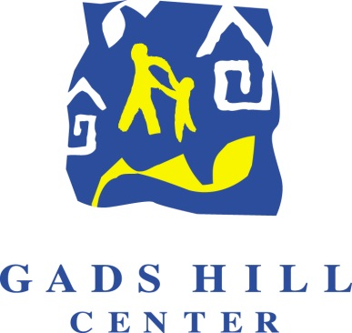

Request for Proposals
PlayStreets! North Region – Summer 2015
Deadline: April 17, 2015
Introduction
Gads Hill Center, in partnership with the United Way of Metropolitan Chicago, has received funding from the Chicago Department of Public Health to implement the PlayStreets! project in the north region of Chicago, defined as community areas 1-32, 76 and 77. This initiative temporarily closes neighborhood streets to transform them into spaces for children and adults to play and engage in vigorous and moderately vigorous activity. It has been successfully implemented across Chicago since 2012.

For summer 2015, over 150 PlayStreets! events will take place across Chicago, at least 75 of which will occur in the north region. These events will be implemented by community-based organizations in 14 target communities. Gads Hill Center is seeking partners to serve neighborhoods where it has not yet established partnerships for this project.
Scope of Services
Successful respondents to this RFP will enter into contract with Gads Hill Center to implement between one and five events in the target community areas. Partner responsibilities include: recommending a safe and appropriate community location for each event and notifying local schools and community organizations; promoting each PlayStreets! event fully throughout the community; providing a minimum of five adults to set up each event, facilitating activities, assisting in program-mandated evaluation and cleaning up the event; recruiting a minimum of 150 community participants for each event (both children and adults) and providing incentives and prizes for participants during the event.

Partners will be expected to provide a firm calendar of dates, times and locations by May 15. Events should be scheduled between June 1 and September 30. Each event should be at minimum three hours in length. If possible, partners should schedule an event for city-wide PlayStreets! day, currently scheduled for Thursday, July 30. Partner staff will collaborate with Gads Hill Center staff to secure street closure permission from residents as required.

PlayStreets! events must be standalone community events and funds may not be used to supplement or support existing events. The goal of these events is to create new opportunities for families to engage in physical activity that would otherwise not exist in the community. Events must be located on a public street – parks, parking lots and other non-street areas are not permitted. Partners will not be reimbursed for any expenses related to events found to occur on locations other than a public street and may have contracts revoked for events held in non-permitted locations. In addition, in keeping with the goals of CDPH’s Healthy Chicago initiative, partners must not offer or permit to be sold unhealthy foods (soda, candy, ice cream, cupcakes, cookies, chips, etc.) at PlayStreets! events.

Funding and Resources
PlayStreets! partners will receive $750 for full and satisfactory completion of each event, up to a maximum of five events. In addition, Gads Hill Center will provide a bounce house and aerobics/Zumba instructor for each event, as well as materials and supplies for a variety of moderately vigorous and vigorous physical activities. A member of Gads Hill Center staff will serve as a liaison to PlayStreets! partners and provide guidance and support in planning and resolving issues.

South Region RFP
The Active Transportation Alliance, World Sport Chicago and LISC Chicago are simultaneously issuing an RFP for the south region of Chicago, defined as community areas 33-75. For a copy of their RFP, please contact Eric Bjorlin at eric@activetrans.org.

Submission and Timeline
All PlayStreets! proposals for the north region are due by 11:59 pm on Friday, April 17. Completed applications should be submitted by e-mail to playstreets@gadshillcenter.org with the subject line “PlayStreets Proposal 2015 – North Region.” The application begins on page 3 of this document and consists of an application form and narrative response questions. Please respond to both sections in this document and return the document electronically.

Decisions will be announced during the first week of May. Partners will be required to submit a complete list of planned dates, times and locations by May 15.

Applications by fax, mail or hand delivery will not be accepted.

PlayStreets! North Region – Summer 2015
Partner Application

Name of Organization:
Main Address: |  |  |  |  |  | Main Phone:
Executive Director Name: |  |  |  |  |  | Phone:
E-mail Address:
Program Contact Name: |  |  |  |  |  | Title:
E-mail Address: |  |  |  |  |  | Phone:
Is the organization a 501(c)3 non-profit?  (applications will not be accepted from for-profit entities) |  |  | Yes  No |  |  |  |  | How many events do you propose to implement?  (minimum of two)
Which of the following communities do you propose to serve?  (Mark with an X) | Rogers Park  Uptown  Albany Park  Montclare  Belmont Cragin |  |  | Hermosa  Avondale  Humboldt Park  Austin  West Garfield Park |  |  |  |  |  |  | East Garfield Park  North Lawndale  South Lawndale  Lower West Side
Please list preliminary dates, times and locations for your proposed events:  Please consider an event for city-wide PlayStreets day – Thursday, July 30 | Event 1 | Event 2 |  |  | Event 3 |  |  |  | Event 4 |  |  | Event 5
 | Date: | Date: |  |  | Date: |  |  |  | Date: |  |  | Date:
 | Time: | Time: |  |  | Time: |  |  |  | Time: |  |  | Time:
 | Location: | Location: |  |  | Location: |  |  |  | Location: |  |  | Location:

PlayStreets! North Region – Summer 2015
Partner Application – Narrative Response Section

- Please describe your experience implementing large-scale community events (including PlayStreets!). Include the number of people attending the event, duration of the event and your assessment of the success of the event.

- What is your plan to attract at minimum 150 children and adults to your events? What resources will you need to make this possible? Do you believe you can attract substantially more than 150 individuals to your event?

- Please describe your plan to provide at least 5 adult volunteers or staff at each PlayStreets! event. Include a description of your staffing structure or any resources that you will leverage.

- Past PlayStreets! events have included activities such as soccer, giant chess, a bounce house, jump rope contests and Zumba. Please indicate what types of activities you plan to include in your events that will specifically attract the community that you propose to serve.

- PlayStreets! events should be held in locations that will best meet the needs of the community. Ideally, these should not be locations within a close vicinity of parks and playgrounds or other existing spaces that already support physical activity. In addition, partners should not hold multiple events in the same location to ensure that the entire community area can be served through these resources. Please explain the rationale for the locations that you are proposing above.

